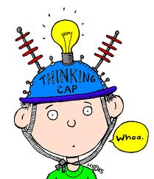
Prompts You Can Ask Yourself, or Your Partner, to Help Make INFERENCES
About Our Characters…

- What kind of person is my character?

- Do I (you) like him/her? Why or Why not?

- Why did the character do that?

- How come the character is feeling this way?

- Do you think he (or she) did the right thing?

- What do you think will happen next?

